This Is A Previous Project + Transaction Extention

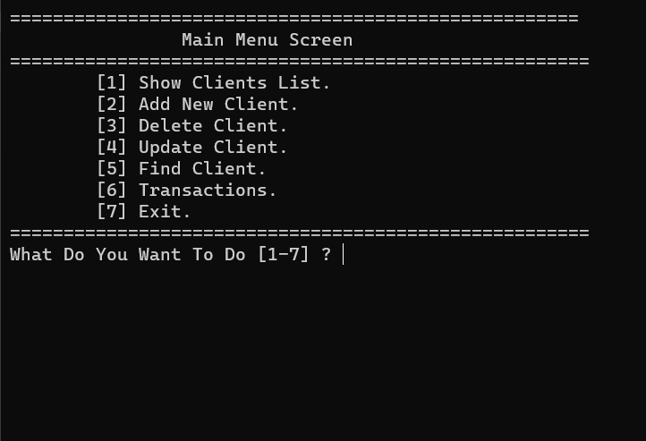

1-Show Clients List From A File (Like Data Base) Inside Project .

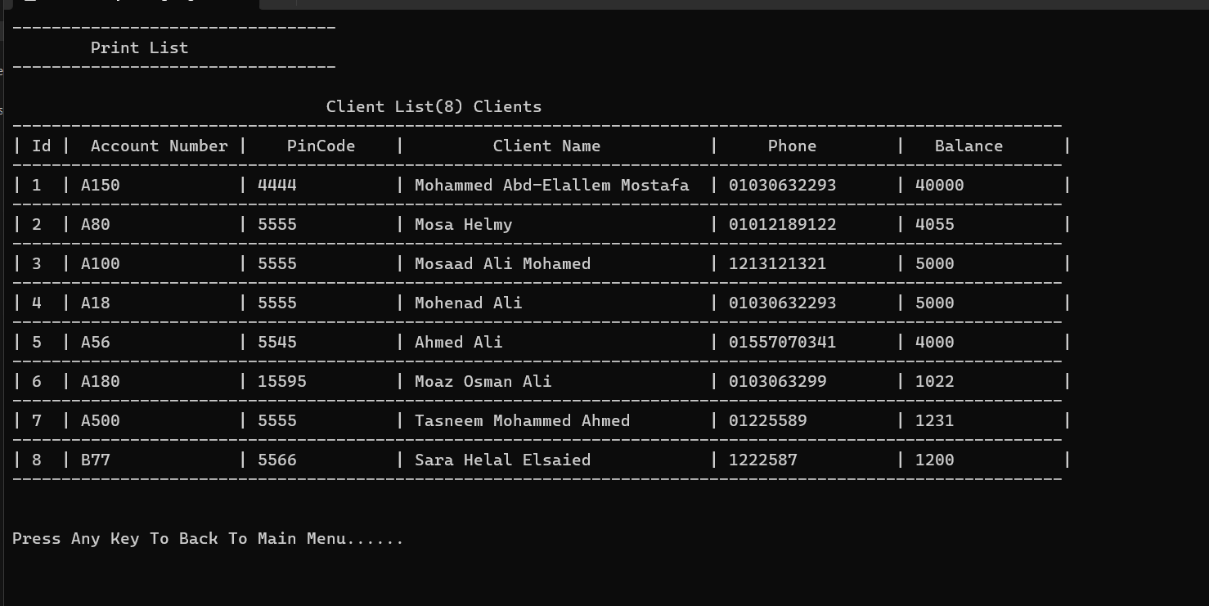

2-Add New Client To The File .

3-Delete Client From The File.

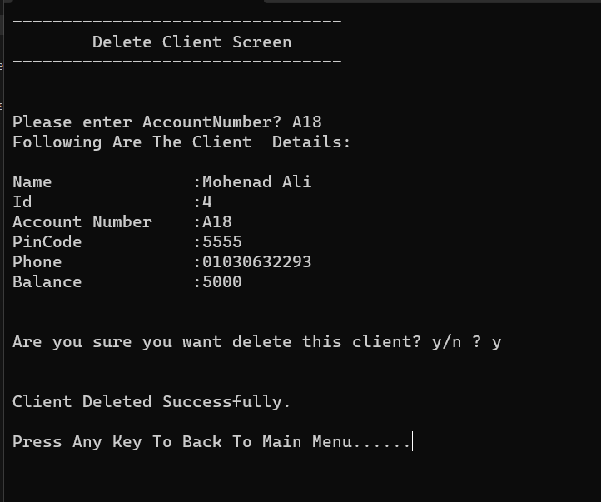

4-Update Client From The File.

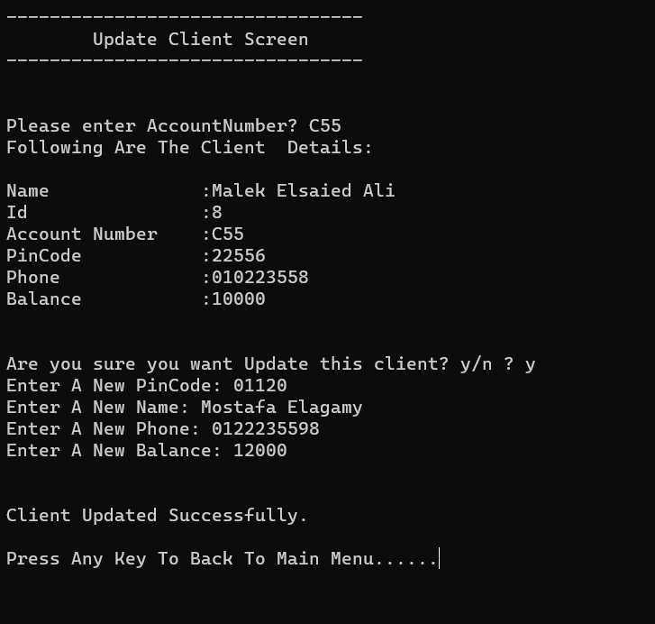

5-Find Client From The File.

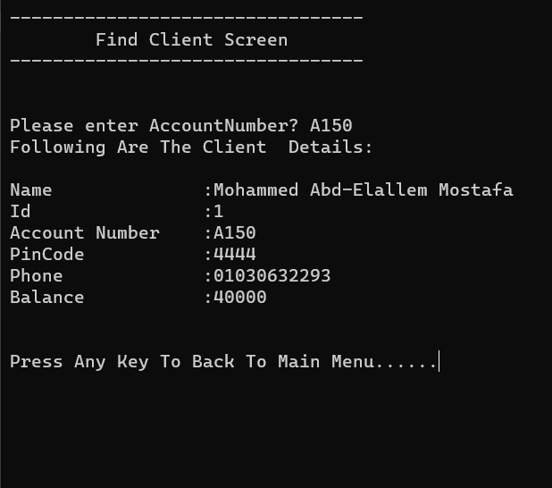

6-Transactions

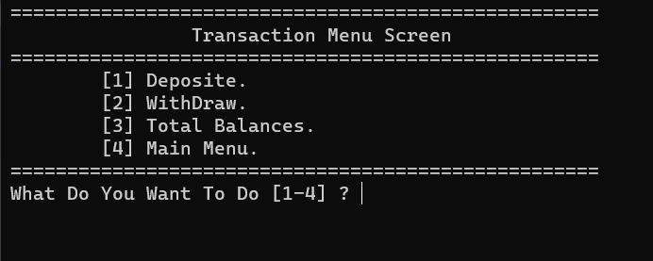

Important Note:

-If You Press 1 And The Program Crashes ->

Delete File Content And Add Clients Again From The Program.